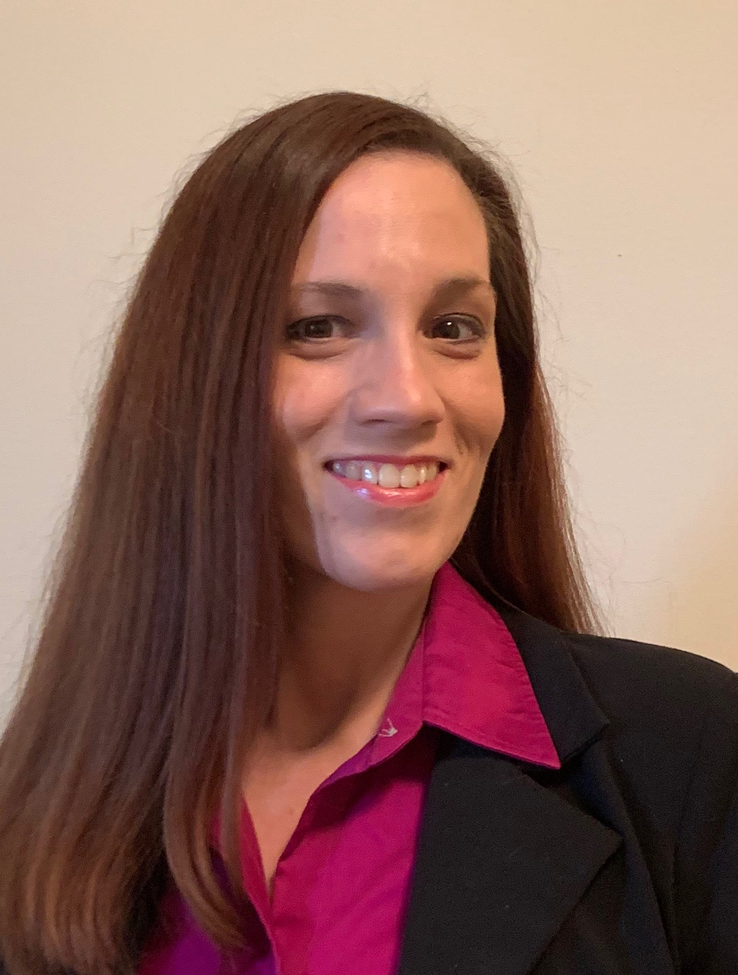

Greetings!

My name is Ms. Menkhus. I was born and raised right here in St. Louis and love what our city has to offer. I am a big fan of the Blues, the Cardinals, and Imo’s!

I graduated from Webster University with a Bachelor's Degree in Psychology and a Master's in Education. I am certified to teach Elementary and Middle School Math. I have taught all ages from newborns through adulthood all over the St. Louis area. I am honored to be here at Gateway Elementary as a 5th-grade teacher.

My teaching philosophy is that students should be taught how to think not what to think. My goal is to help each one of my students grow academically, emotionally, and socially while we prepare for middle school.



* Iced Coffee
* Chocolate
* Disney
* Traveling
* Painting Furniture
* Manners

**Materials needed for virtual learning:** Contact me through [ClassDojo](https://teach.classdojo.com/#/classes/5f3be3bfb55d4e3d7dcd3cc5/points)



1. [](https://teach.classdojo.com/#/classes/5f3be3bfb55d4e3d7dcd3cc5/points)ipad and charger
2. Headphones
3. Paper/ notebooks
4. Pencils/Pens
5. TEAMS Log in (email and password)
6. A great attitude!

[Jessica.menkhus@slps.org](mailto:Jessica.menkhus@slps.org)

I truly believe in good communication with my students/parents to make this last year of Elementary school unique and special We are all a family! Know you can reach out to me!

This will be a year that we will have a fun, have new experience and most important we are going to learn a lot!!

-Ms. Menkhus